DJI NAZA-M LITE REPAIR MANUAL
F330 FRAME

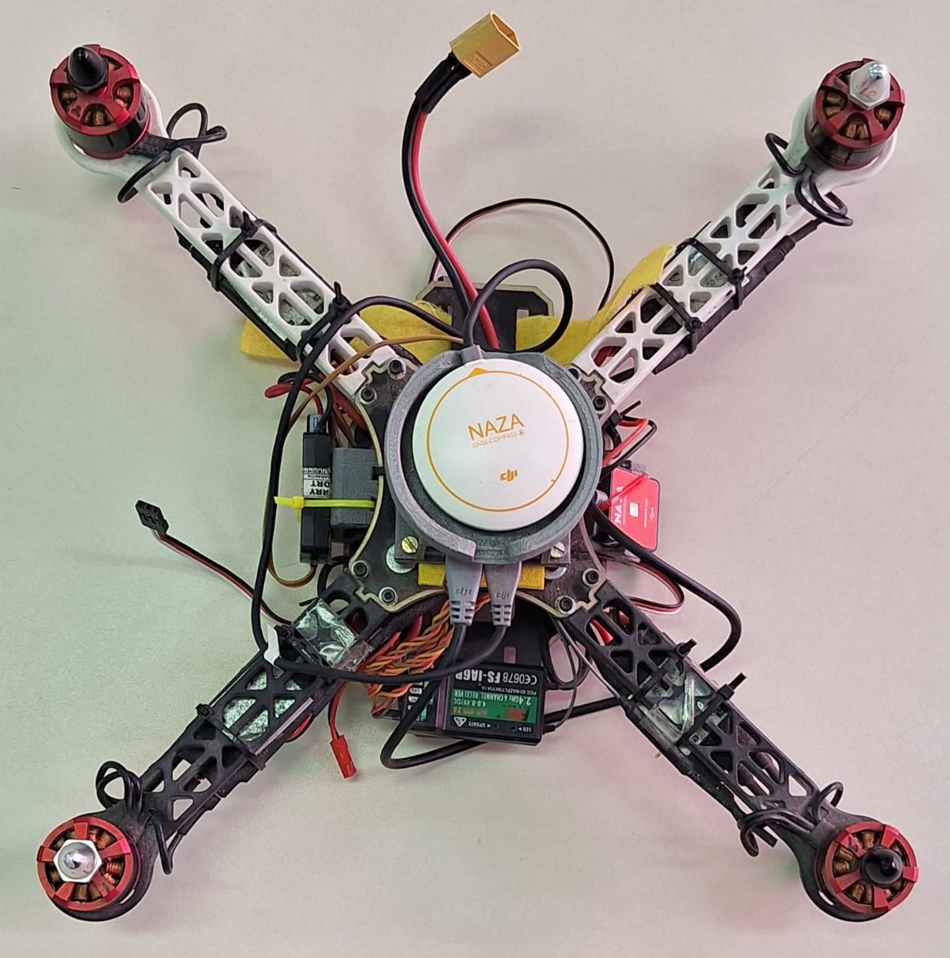

Repair Instructions

- Check components & replace malfunctioning ones
- Download drivers & update firmware
- Ground control setup, Flight calibration & Tests
- Final result

Check & replace components

Use a lipo bettery cell checker and servo tester to test the four brushless motors and the battery integrity, wich in this case was ok.
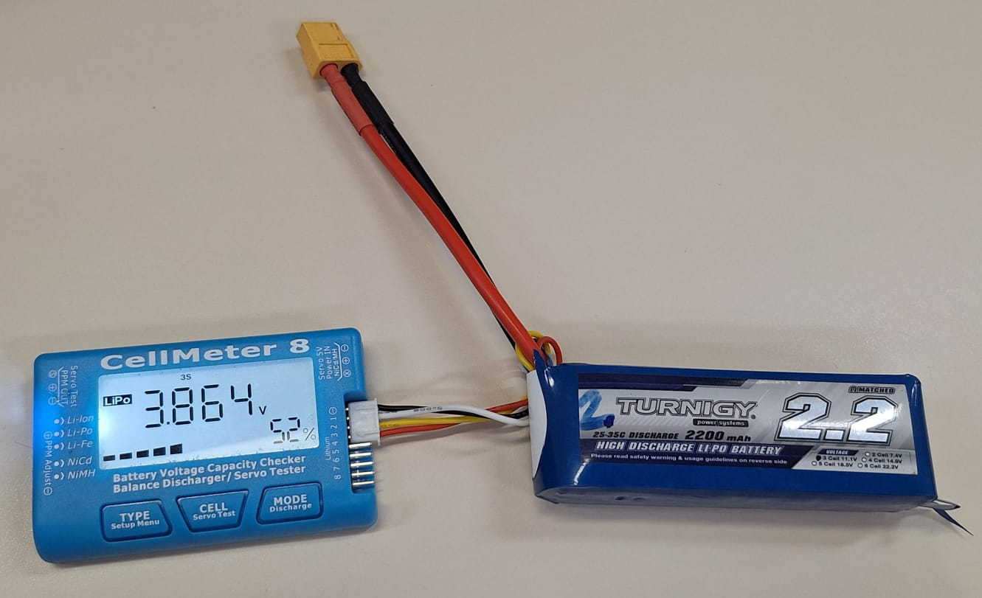
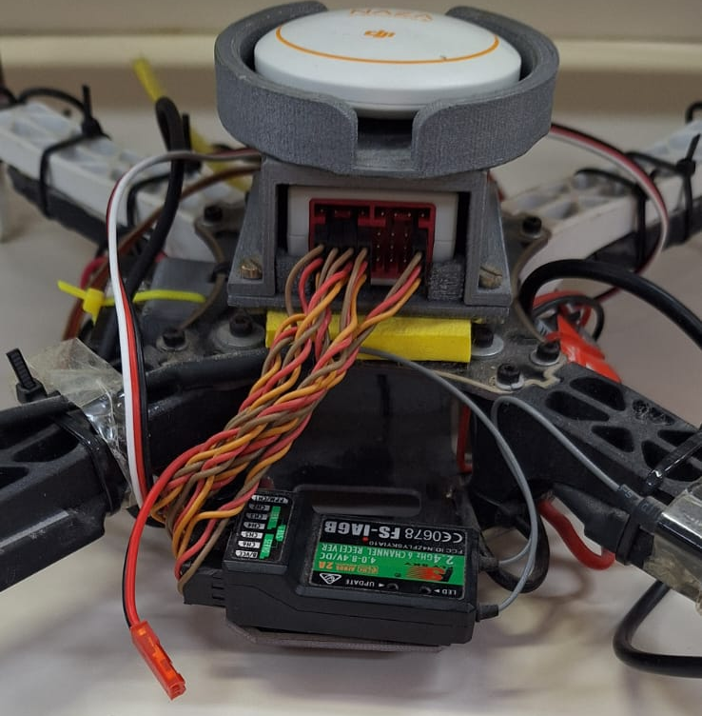
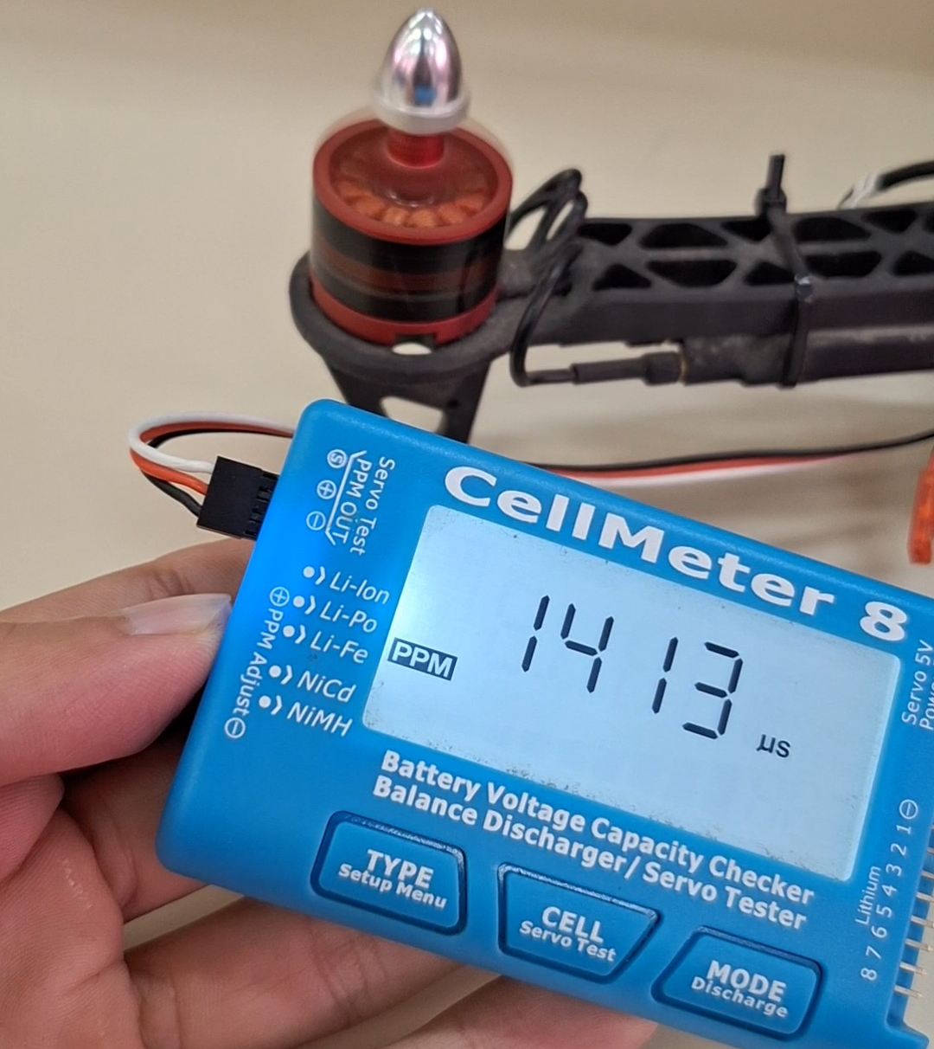
The previous remote controller was lost, so the receiver wil have to be replaced.

Disconnect the old receiver → plug the battery to the drone → connect one motor to the receiver to power it on → click the bind button on the receiver → in the RC select bind set > start. It should appear a “succesfull bind” message.
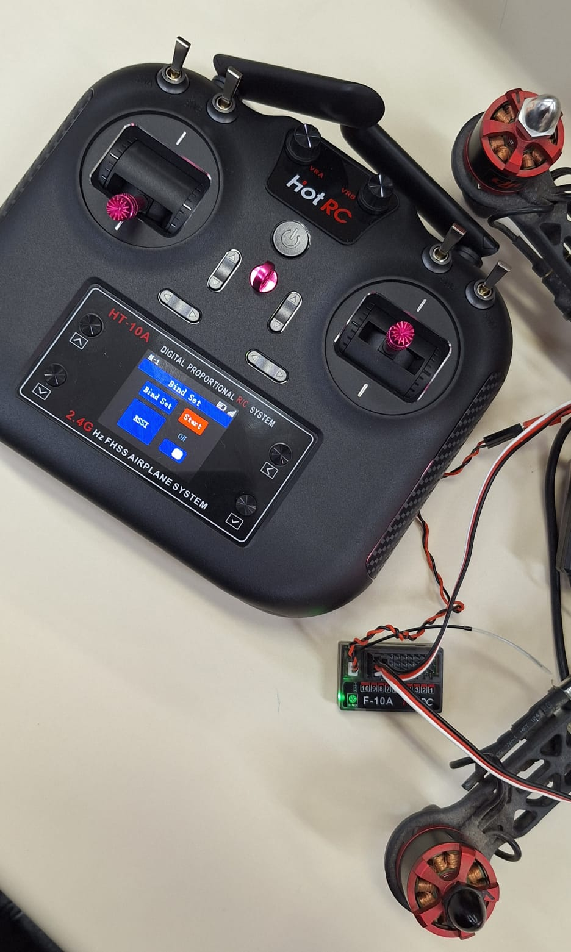
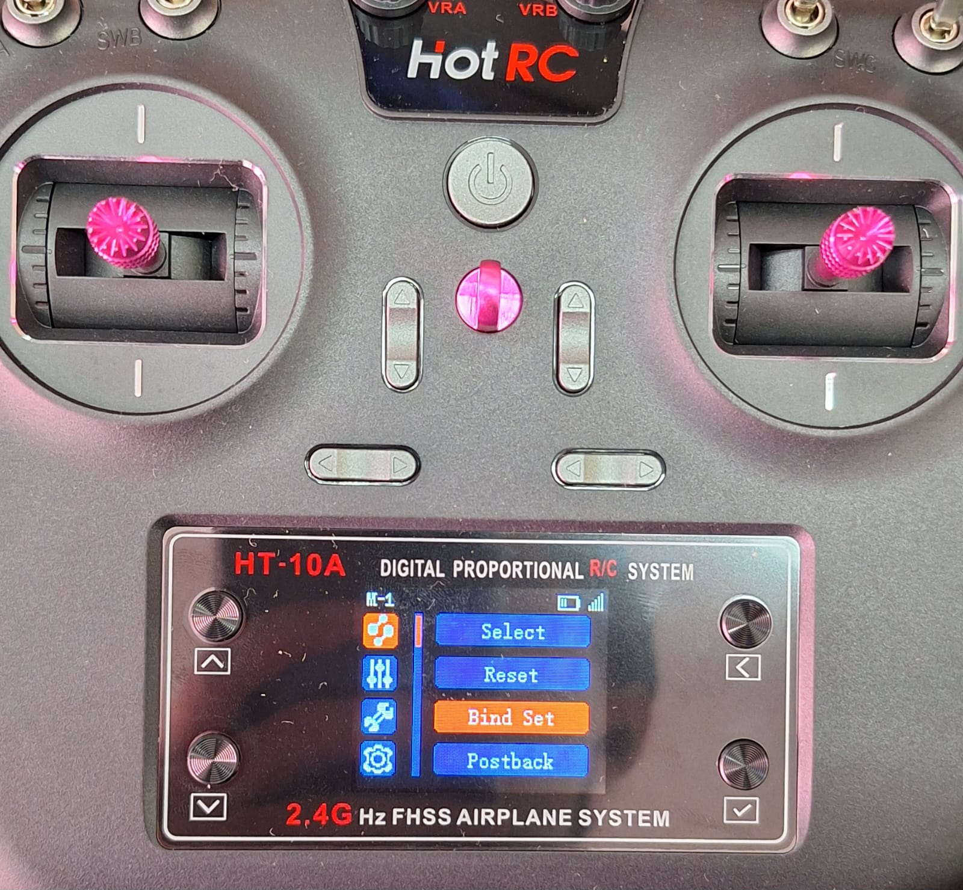
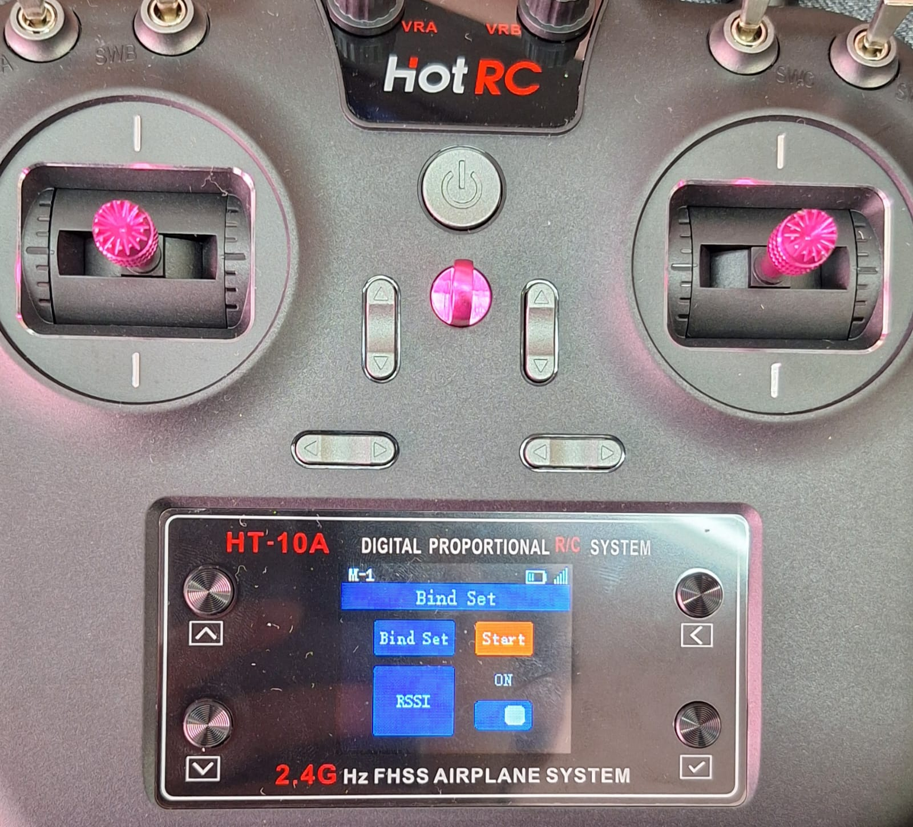
After binding, calibrate the four motors to the remote controller, for ach one follow these steps:
Unplug the baterry → connect one motor to CH3 (default calibration channel) → put the throttle stick in maximum up position →plug the battery, it should make a beep to signalize the calibration started → put the throttle stick in maximum down position, it should make a beep to signalize it is calibrated → Repeat the process for the remaining motors

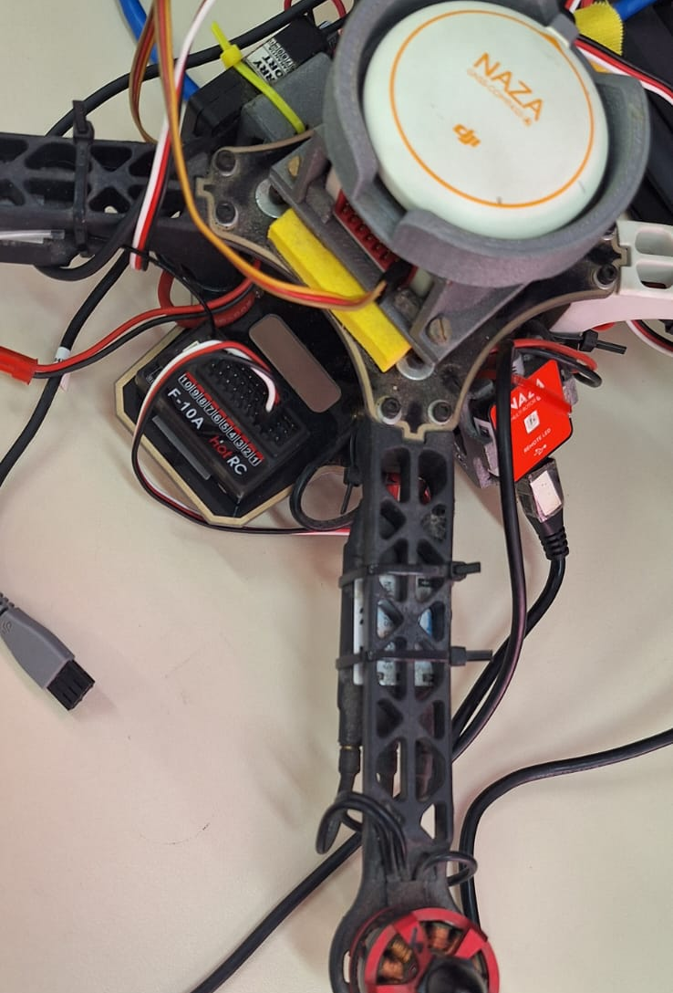

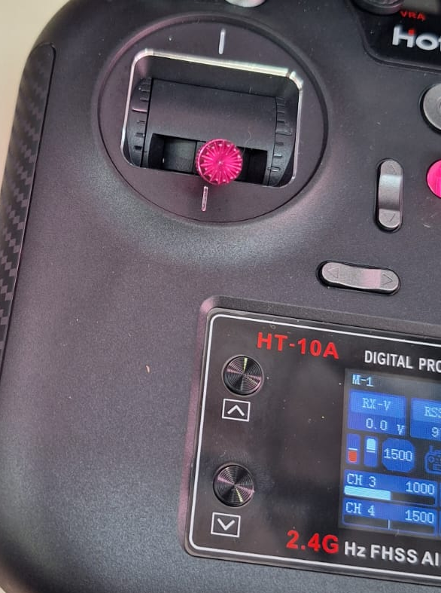
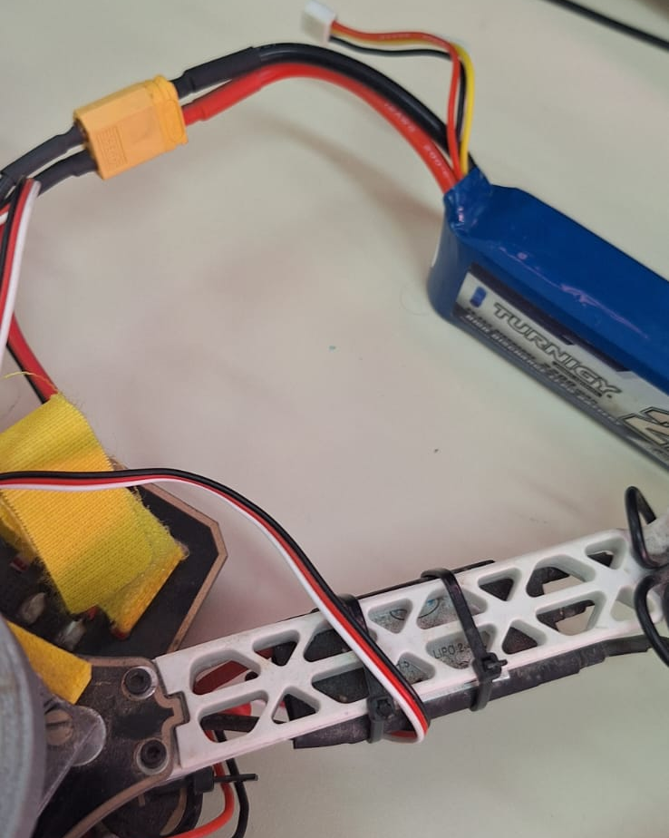
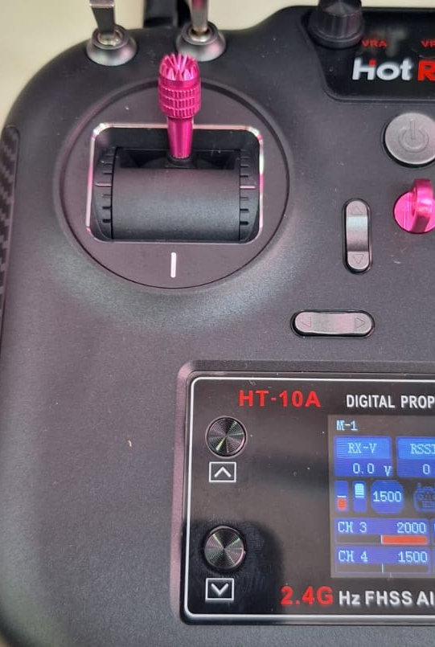
Connect the new receiver channels to the main controller according to the manual. In this case:
A – CH1 (Roll)
E – CH2 (Elevator)
T – CH3 (Throtle)
R – CH4 (Rudder)
U – CH5 (Flight modes)
If you want to add more functions to the RC, connect the X1, X2 and X3, then configure each function in naza assistant later.
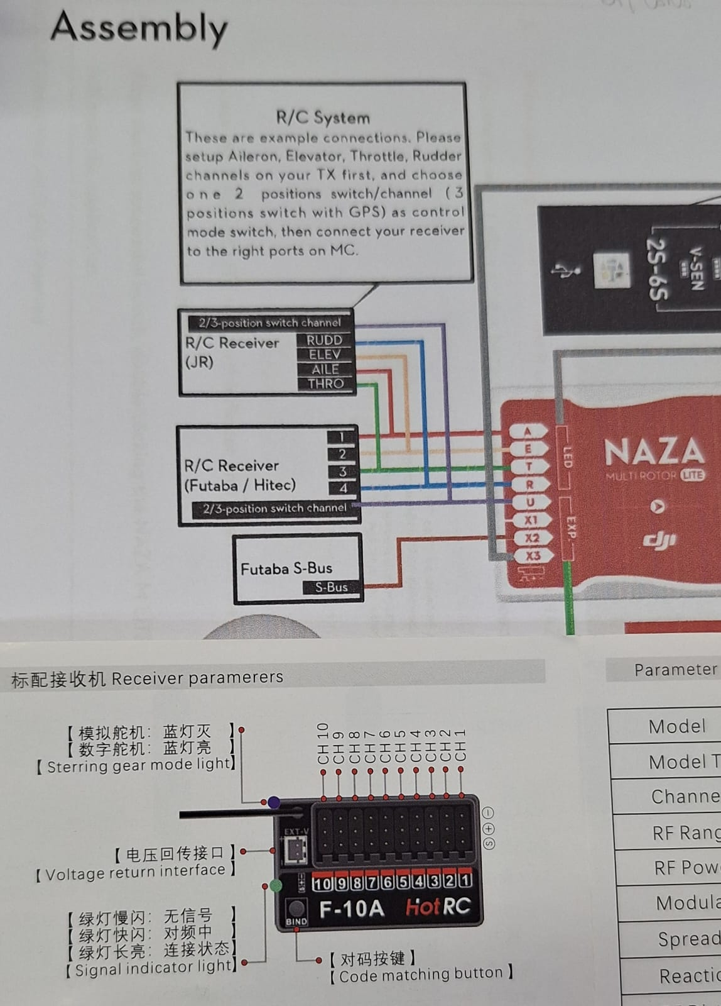

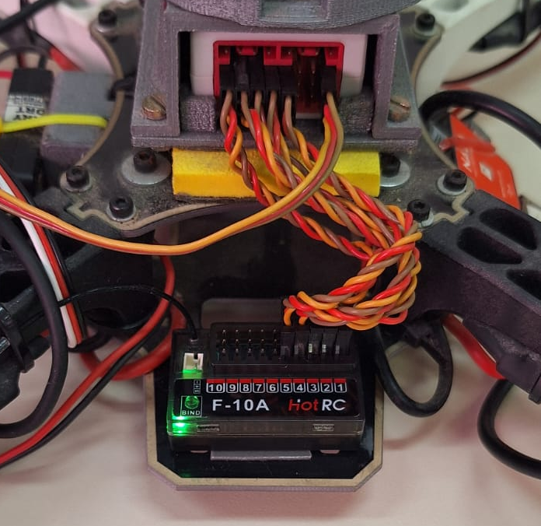

Download drivers & Update firmware
First, install naza m-lite assistant and WIN drivers in dji’s site.
https://www.dji.com/br/downloads/products/naza-m-lite#tuning_params
https://www.dji.com/br/downloads/softwares/other-dji-win
After installing follow these steps on windows:
1. Disable driver signature enforcement to install dji drivers (It think It’s a virus beacause it doesn’t have digital signature)
> Settings → System → Recovery → Advanced startup (click Restart now) → Troubleshoot → Advanced options → Startup Settings → Restart → Press F7
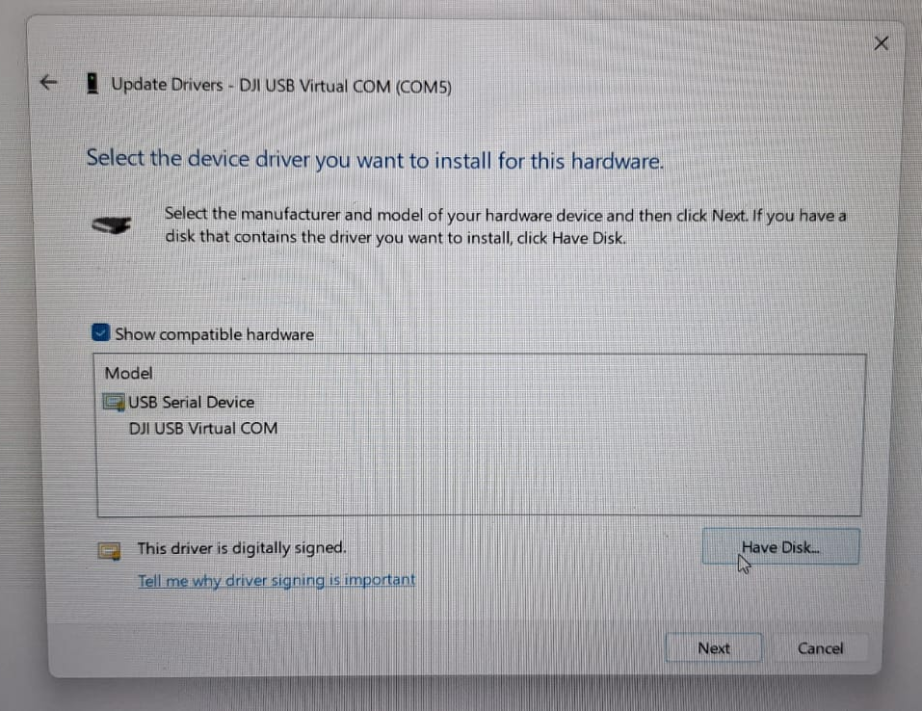
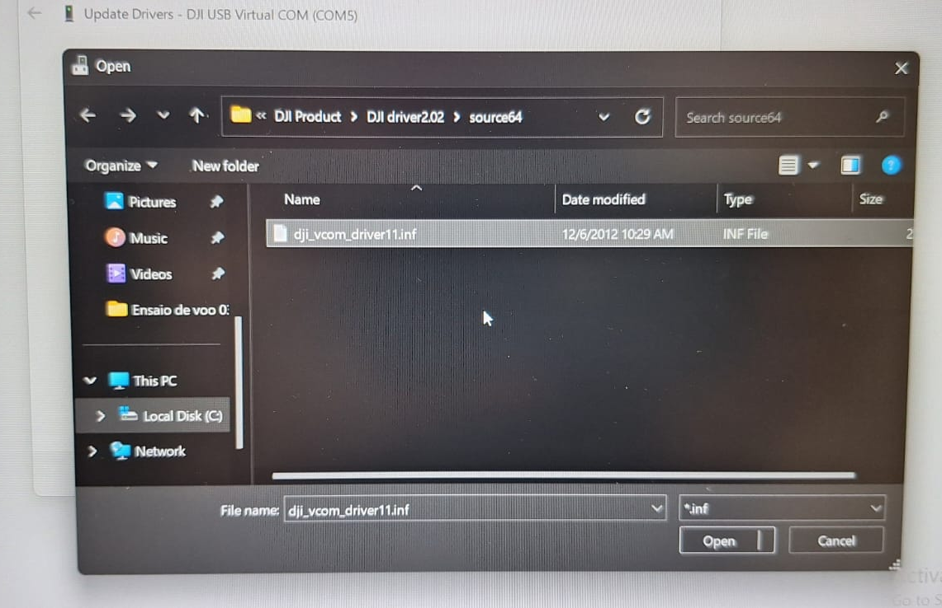
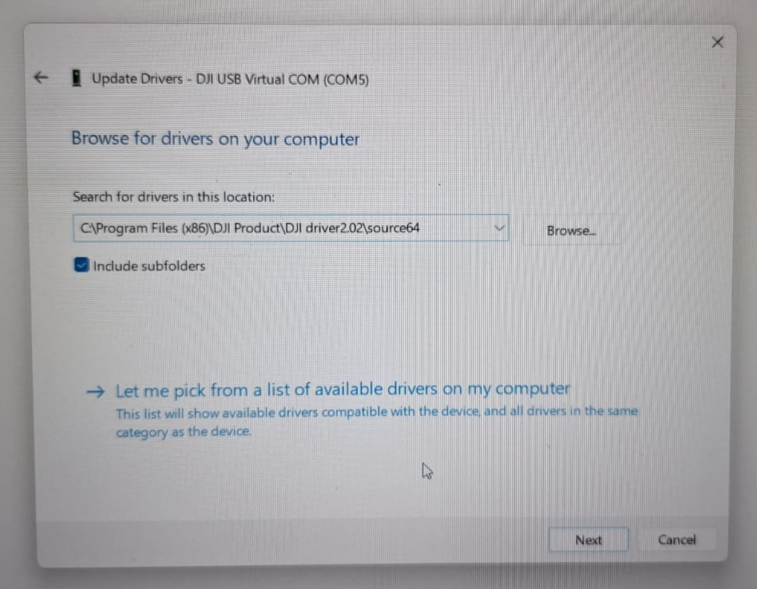
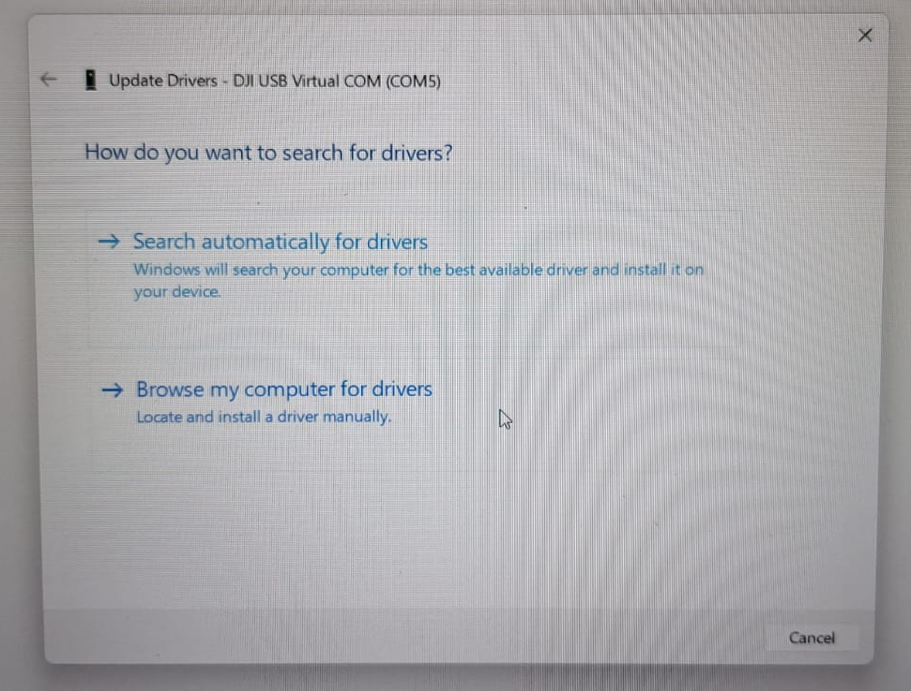
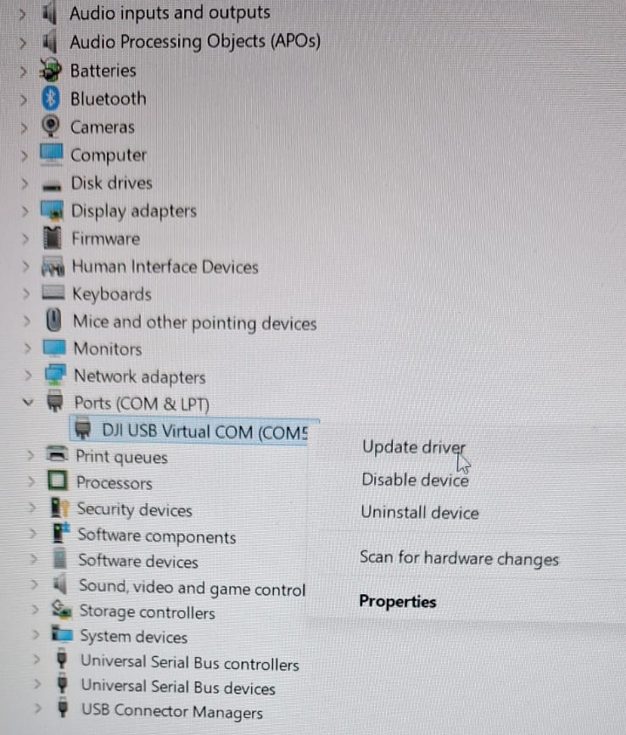
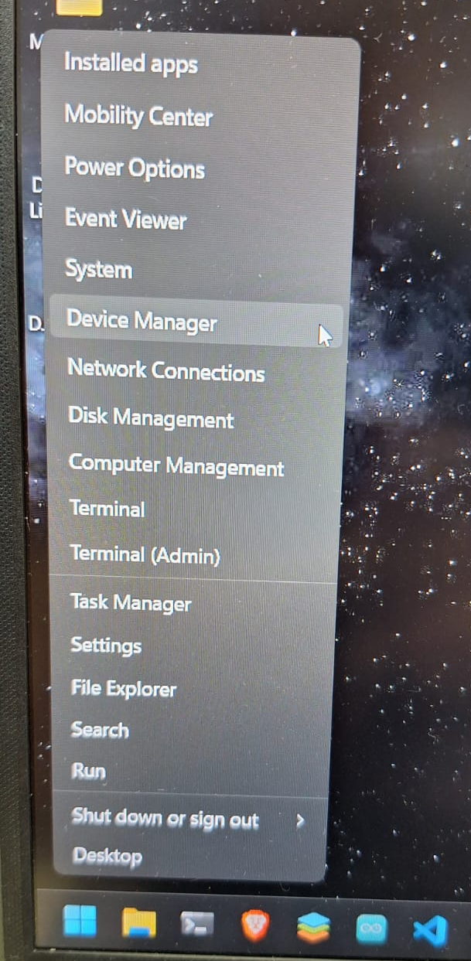
2. Execute the exe with privileges in windows power shell as admin
> Start-Process -FilePath "C:\Users\[user]\OneDrive\Desktop\DJI_WIN_Driver_Installer.exe" -Verb RunAs
Connect the main controller to your PC → Device manager → COM and LPT ports → serial USB device (COM5) → update driver → browse my computer for drivers → let me pick from a list of available drivers on my computer → have disk... → browse → select DJI driver in DJI product folder

If you followed the steps correctly, your computer should recognize the main controller and you can now configure the drone in the flight assistant.
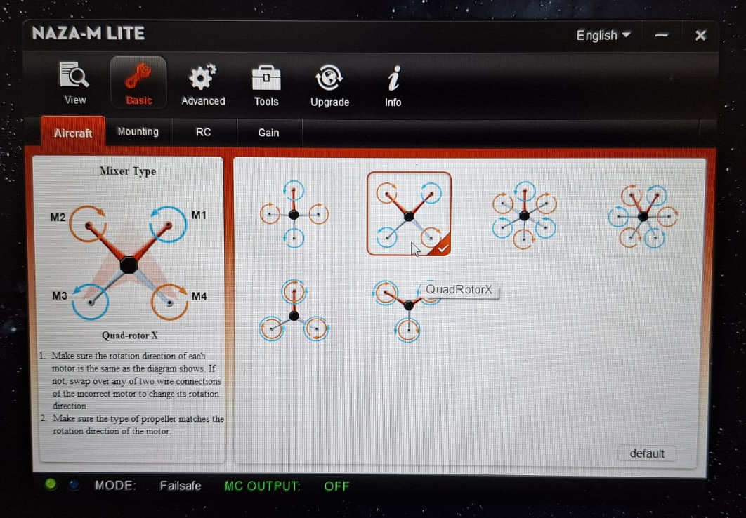
Ground control setup, calibration & tests

Execute naza assistant → configure as quad-rotorX or quad-rotor 1 according to the wiring of the motors

